**Graded Assignment**

**Group Name: 2A-S2**

**Group members:**

**Anubhab Gupta**

**Arpit Joshi**

**Palak Choudhary**

**Aditya Shahi**

**Ritesh Kumar**

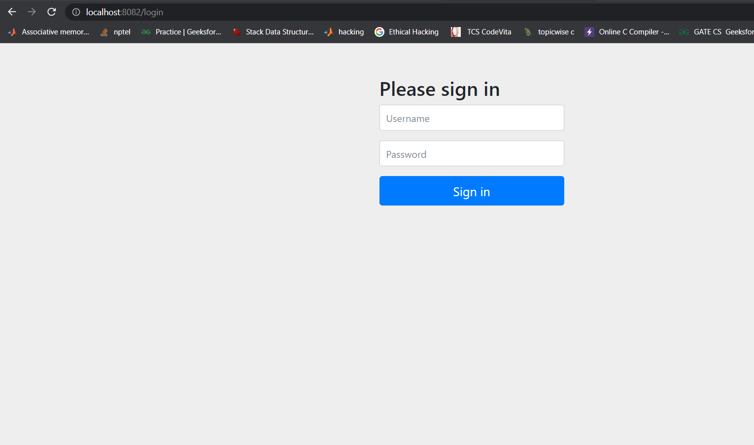

Login Screen

In this project we have bootstrap two types of user as follows:

1. Role: USER, Username: user, Password: user.
2. Role: ADMIN, Username: admin, Password: admin.

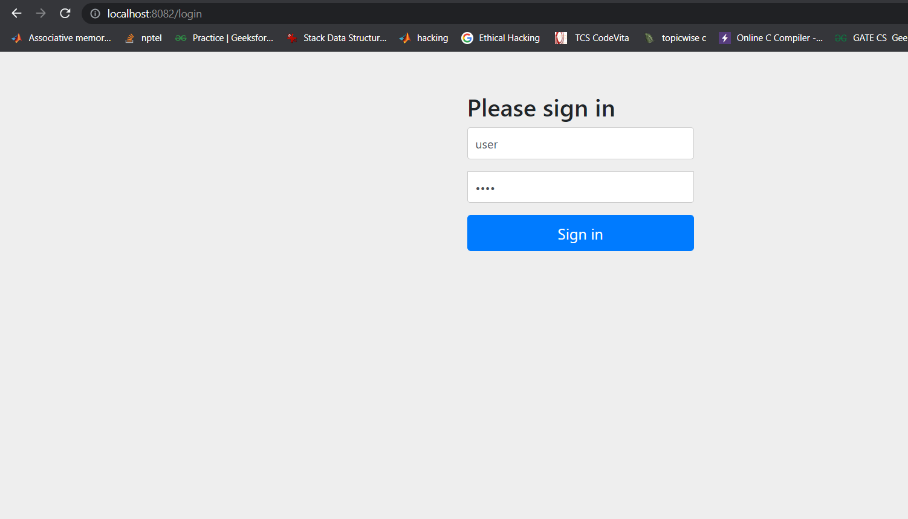

User Login screen

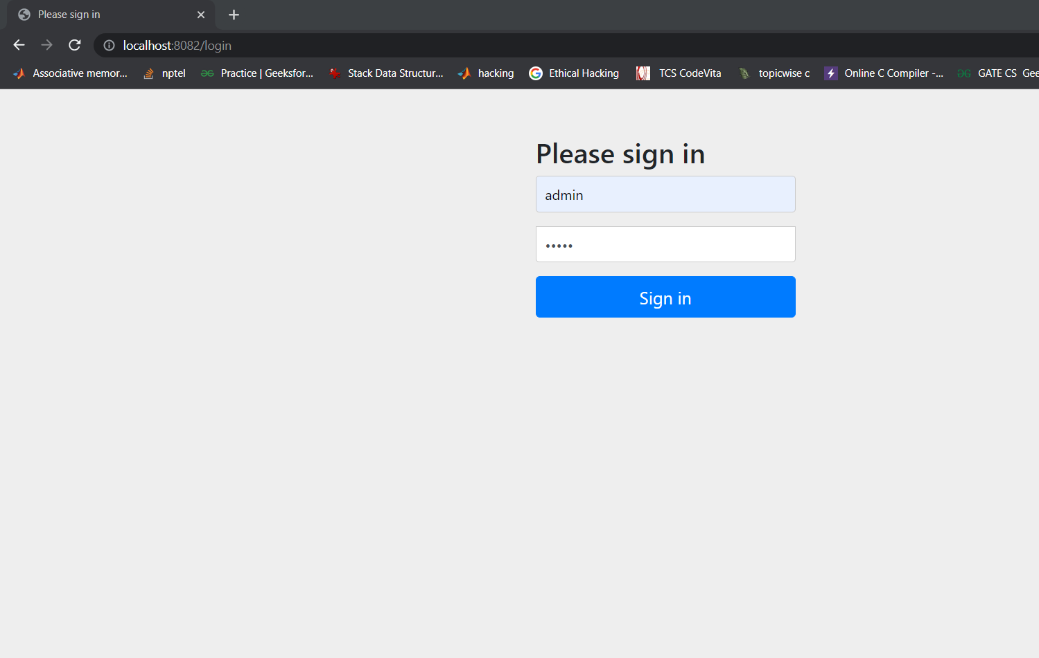

Admin login screen

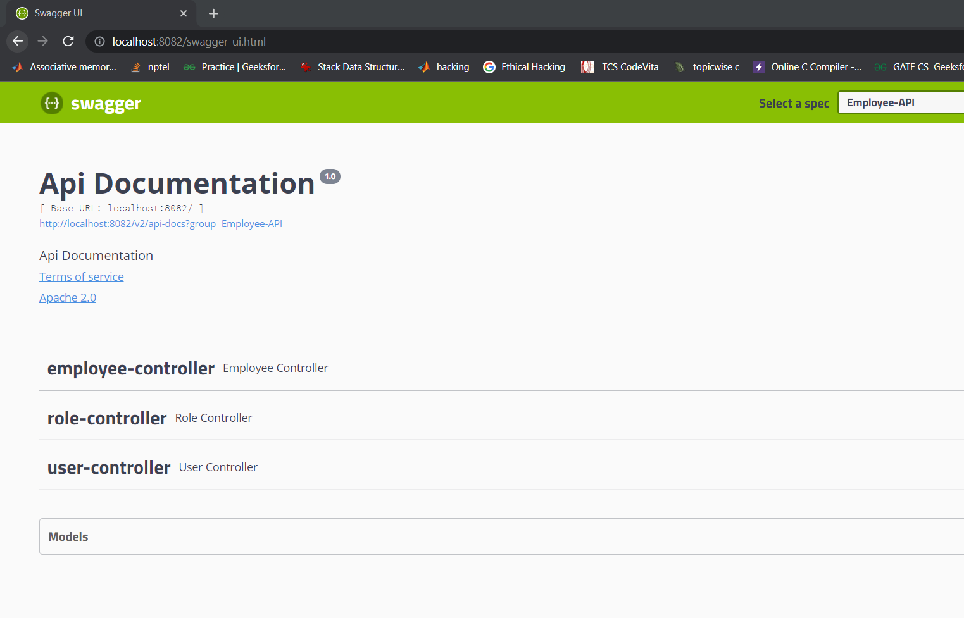

Swagger UI

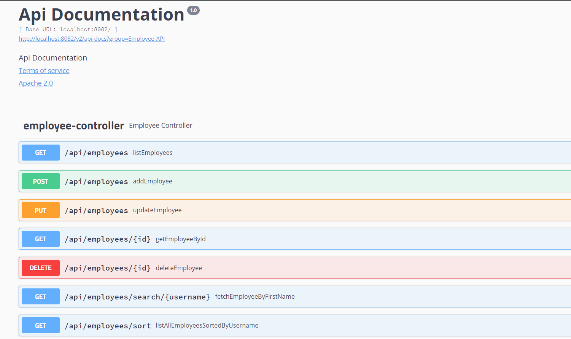

Employee Controller Apis

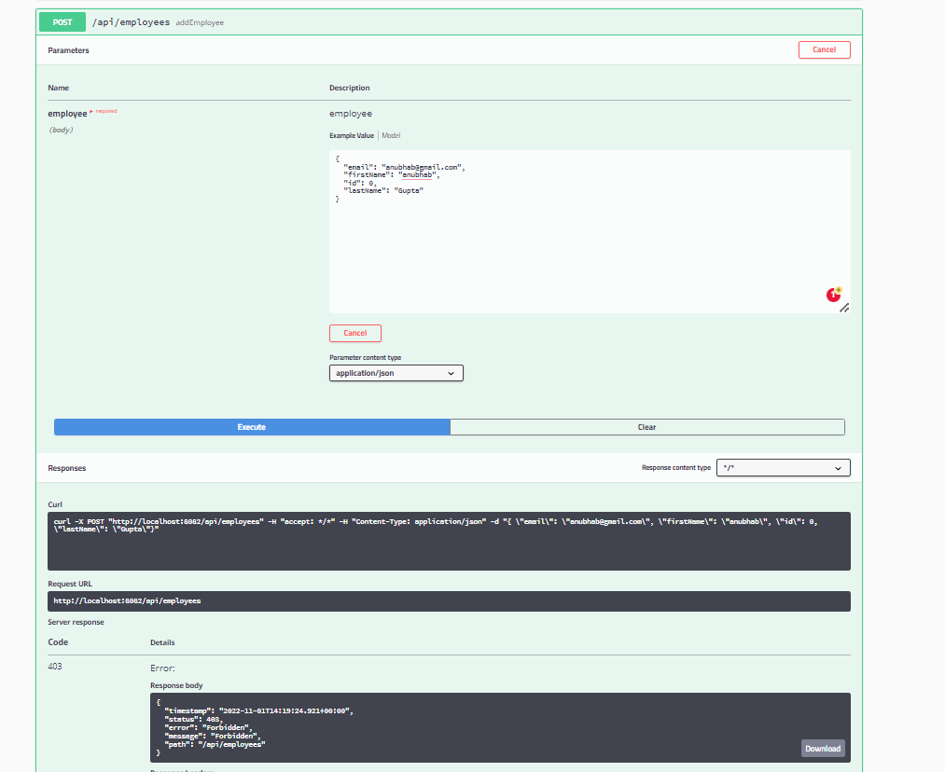

From user role when we try to add employee it will show 403 Forbidden error as show above. USER role does not have access to add employees.

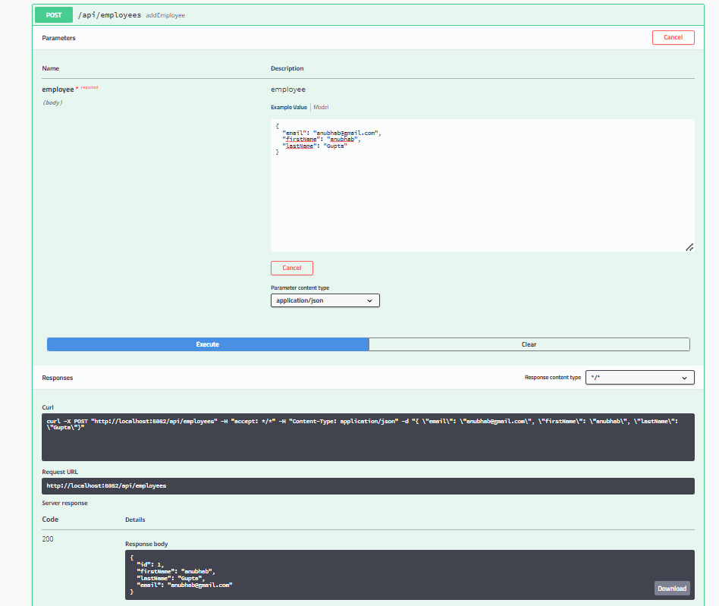

Admin role can add employee as ADMIN role as access to add employee as shown above.

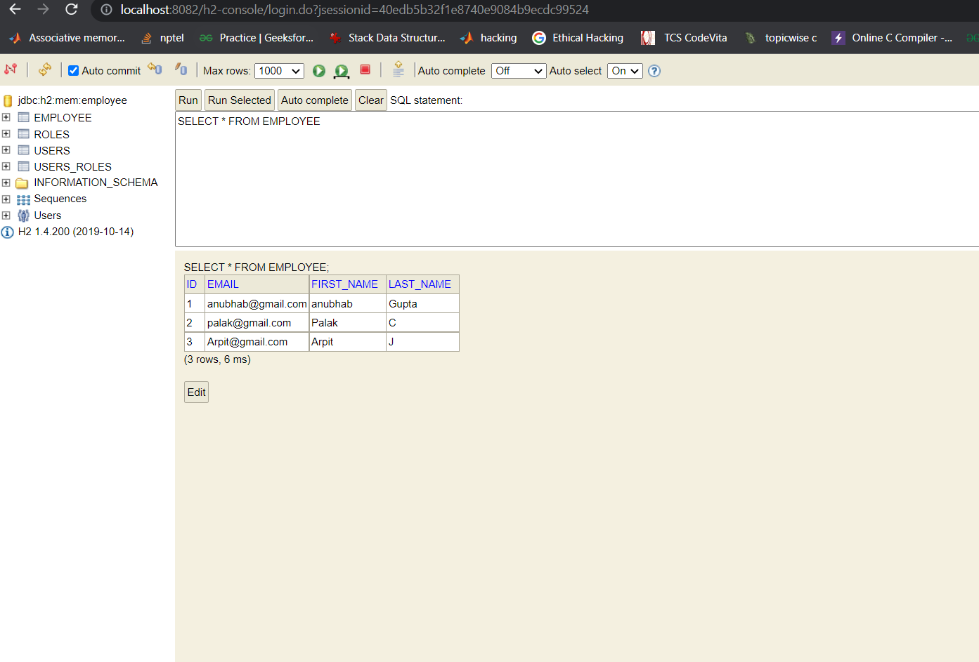

As shown in above screenshot admin can add employee and the screenshot of H2 database with employees details is shown above.

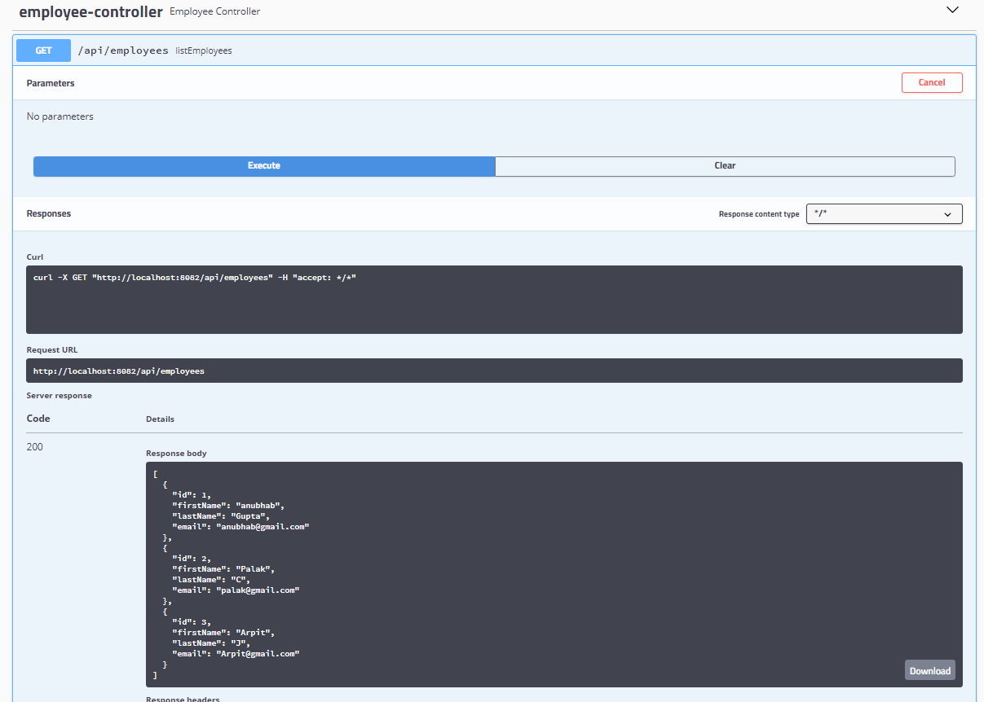

This is getAllEmployee api, which can be accessible for both users and admin. This will give us the list of employees.

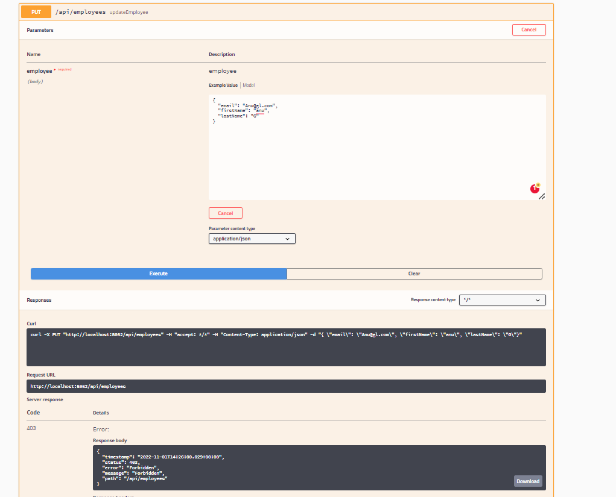

User role can not update employees details, if we try to update it will give 403 forbidden error as shown above.

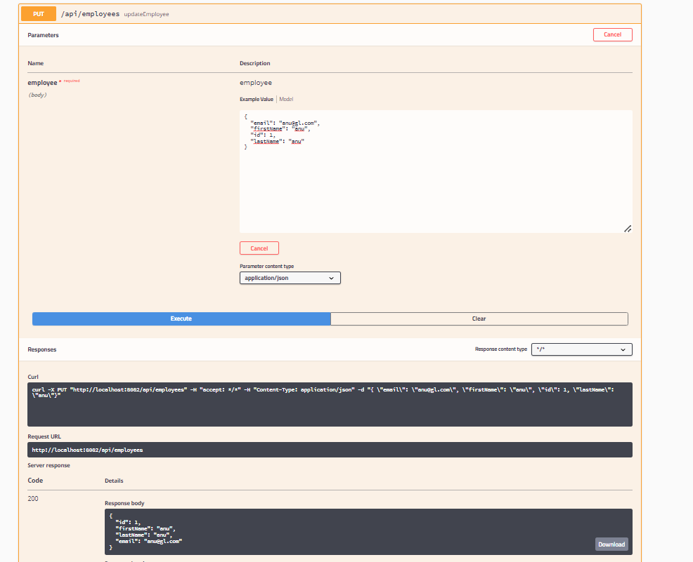

ADMIN role have the access to update the employee details. So admin can change or update employees details as shown above.

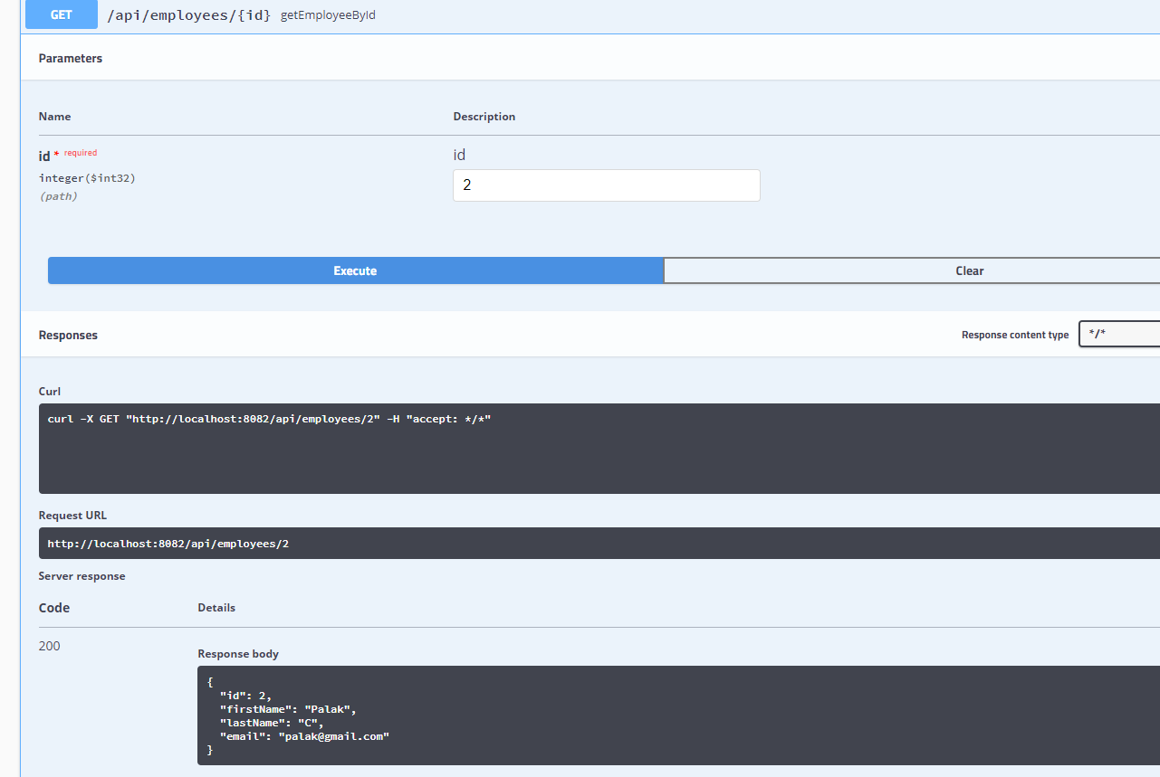

This is getEmployeeById api, which can be accessible for both users and admin. This will give us the details of employee by Id as shown above.

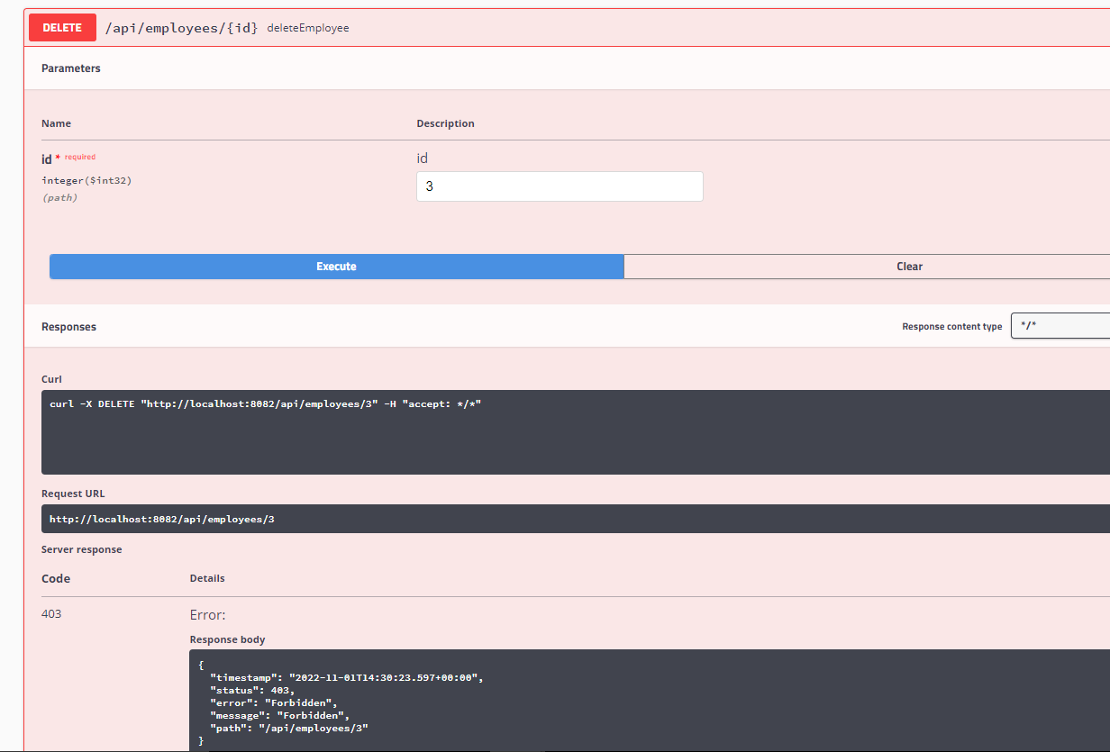

User role do not have access to delete employee by id. If user try to delete any employee it will give 403 Forbidden Error as shown above.

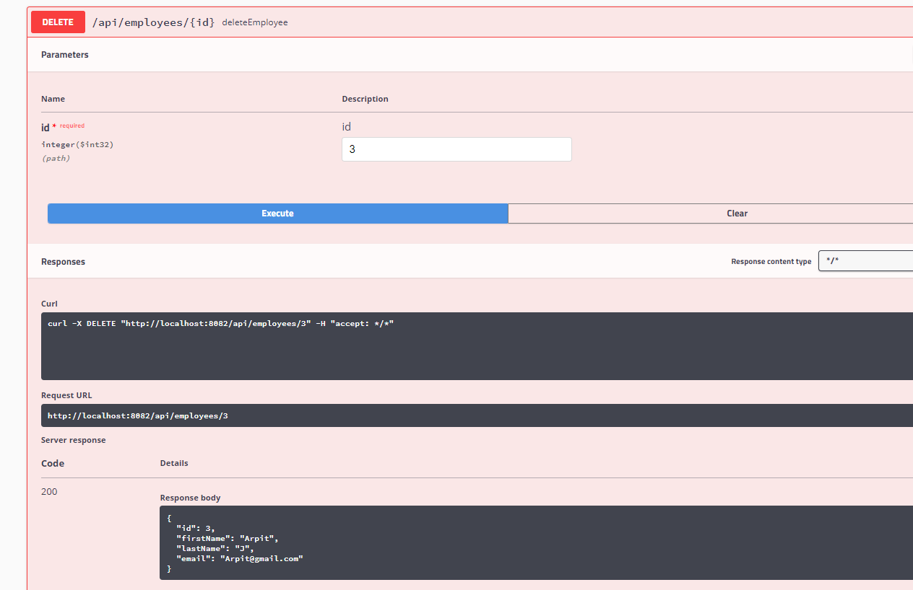

Admin role have access to delete employee by id as shown above.

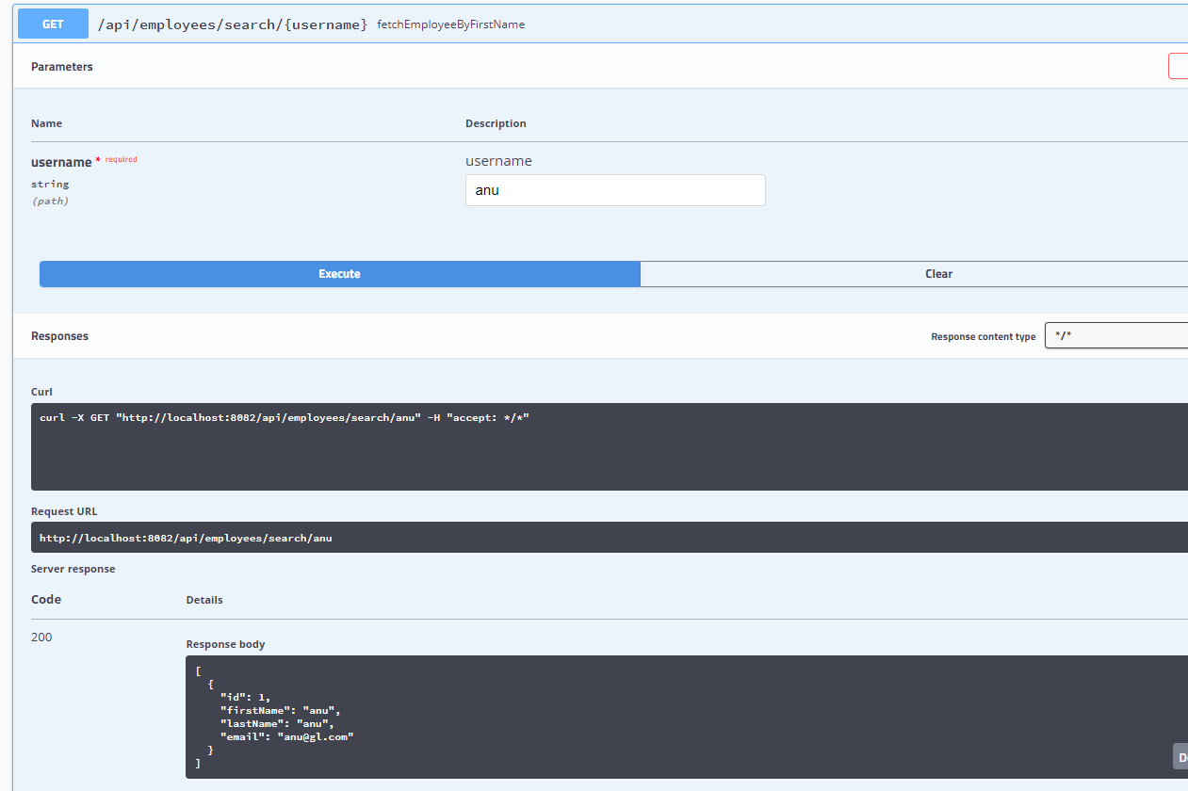

This api is accessible for both user and admin role. In this api we can search employee by user name. This will give employees details by username.

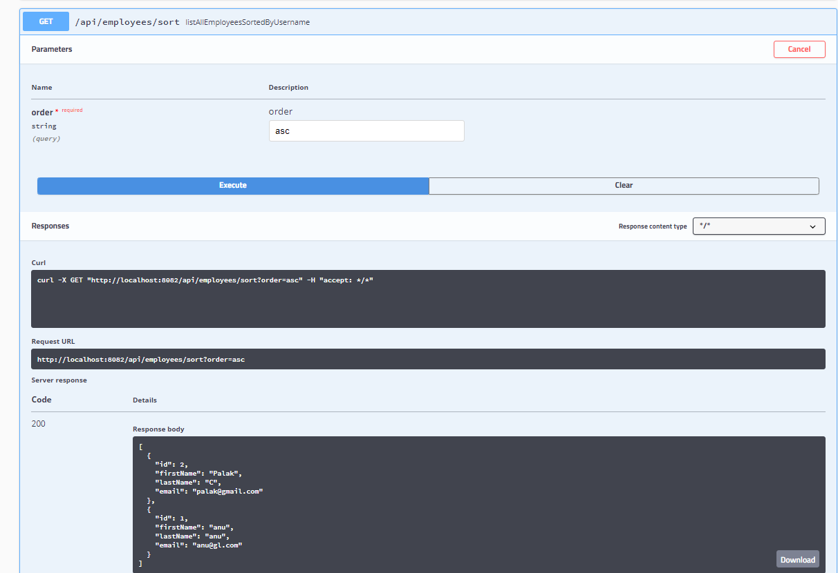

This api is accessible for both user and admin role. In this api we can sort employees by firstname in both asc | dsc according to the payload passed while calling api.

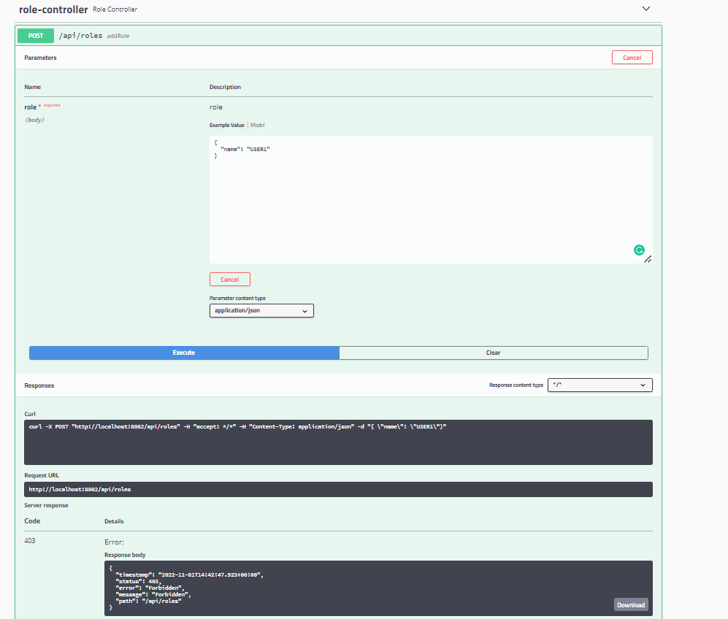

This is an api to add roles. This api cannot be accessible by user role. If user try to add roles then it will give 403 Forbidden error.

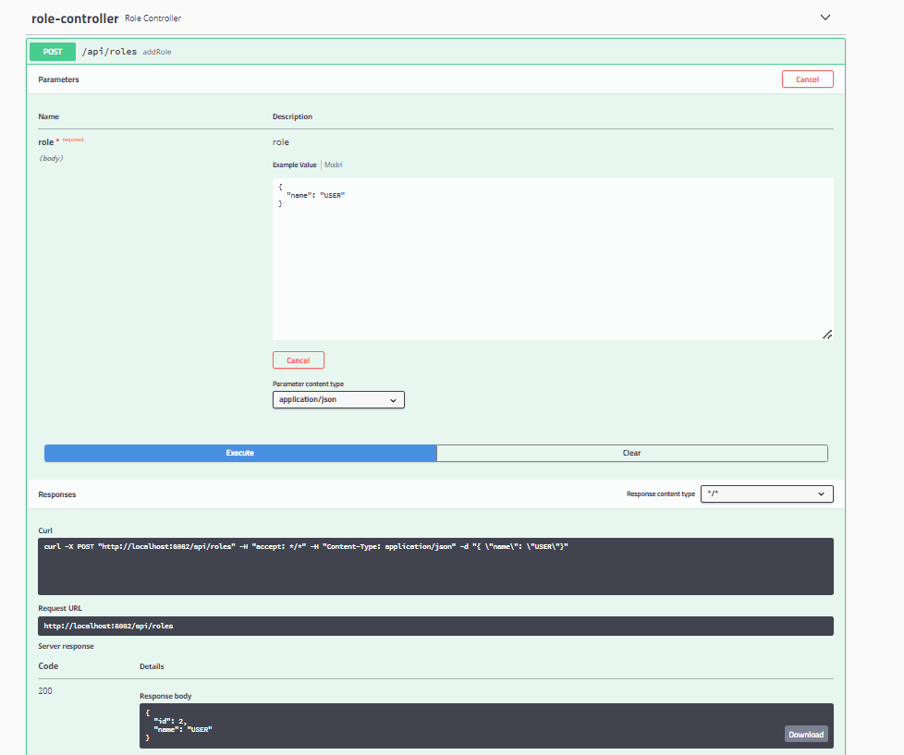

This is an api to add roles. This api be accessible by admin role. Admin can add roles as shown above.

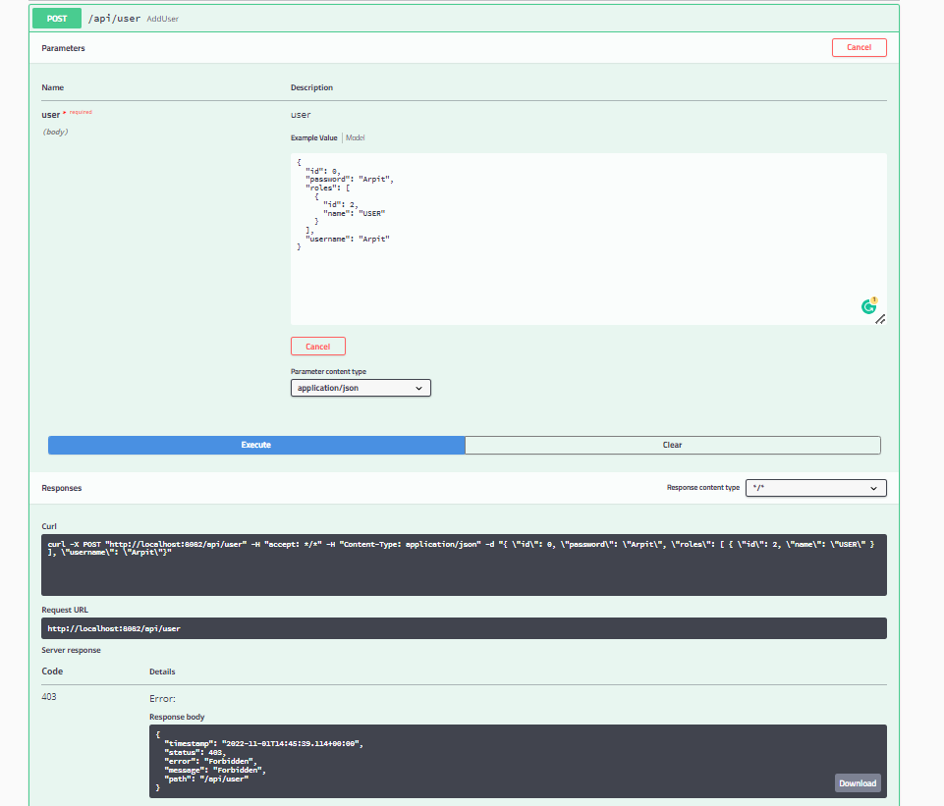

User role do not have access to add user. It will give 403 forbidden error if user tries to do so as shown above.

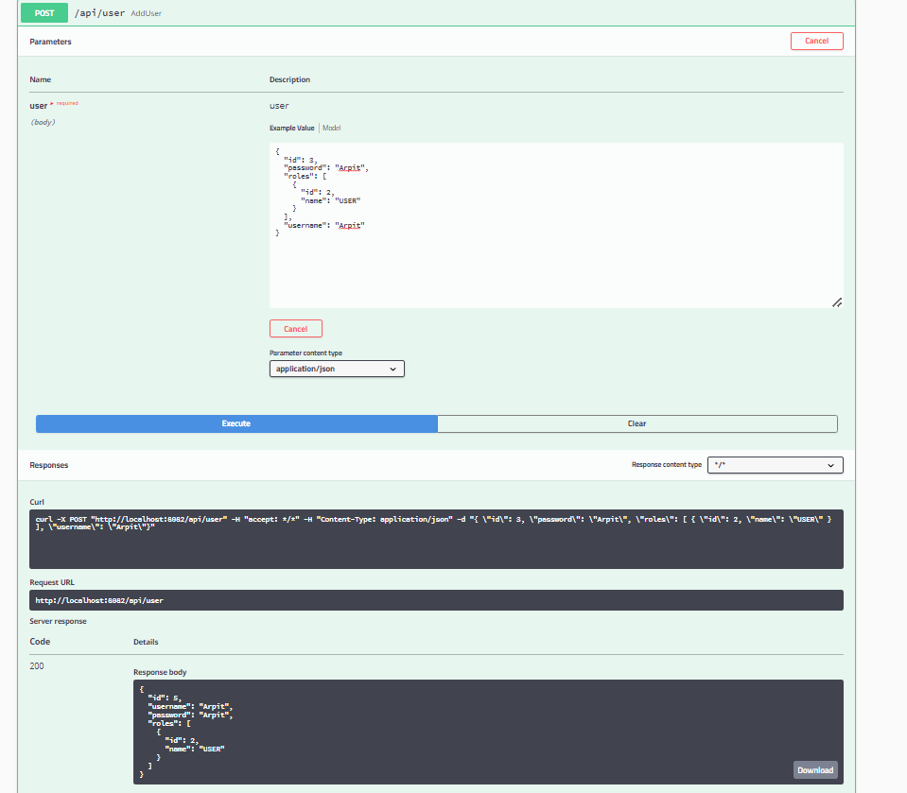

Admin role have access to this add user api. Admin can add user as shown above.